

Noyes USB Instrument Driver Installation on Windows 98/2000

Extract the files from the distribution file and place in a known directory.

- Plug in the Instrument.
- When the Found New Hardware Wizard box appears, Click Next.

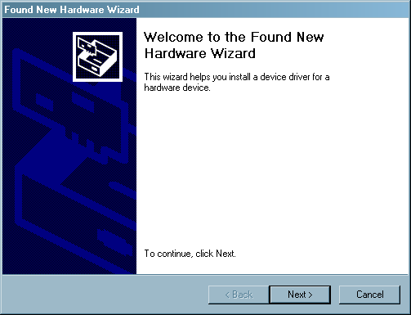

- Select “Search for a suitable driver…”, Click Next.

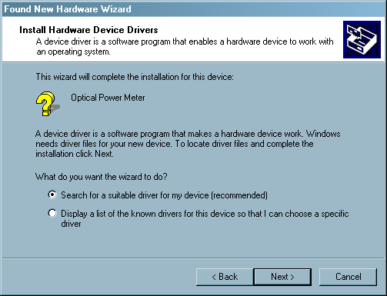

- The Locate Driver Files dialog box will appear. Select “Specify a location” and Click Next.

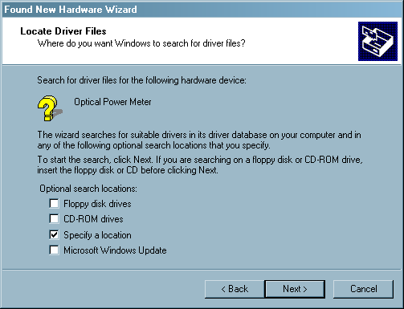

- Select the location where the driver files were extracted and Click OK.

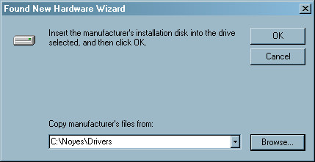

- After the Wizard finds the driver files, click Next.

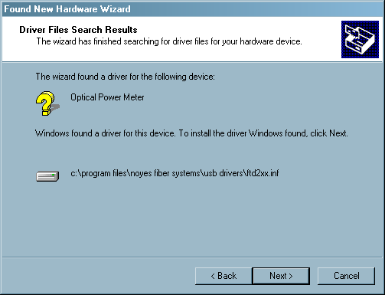

- The Completing the Found New Hardware Wizard box will appear. Click Finish.

